Huffman Documentation

The source code for this program is uploaded in my portfolio, the executable program is uploaded to my github repository: <https://github.com/BigMX/Guildhall-Huffman-Exercise> because this program is created with Qt widget and requires many dependency file for GUI display.

Intent

This program uses Huffman compression algorithm to compress and decompress files. The intent of this program is to better manage files, and allow user to preview the info of processed file.

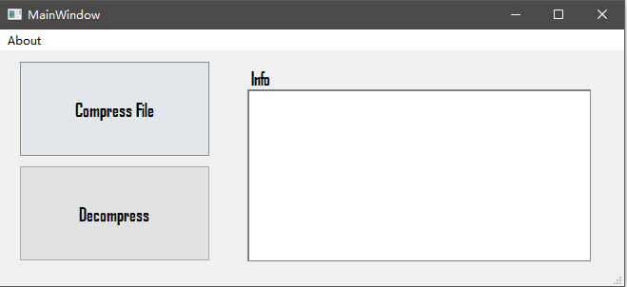

Scope

This application is written in C++ and the GUI is made with Qt Widget tools. In this program, user can choose file to compress and decompress. The info field will show up the size change and the processed text.

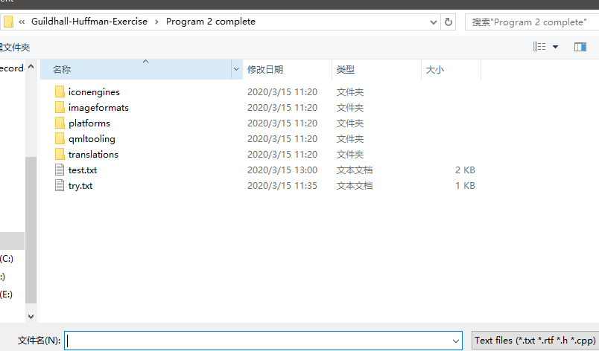

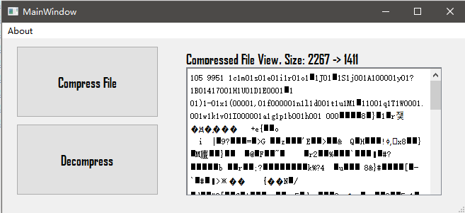

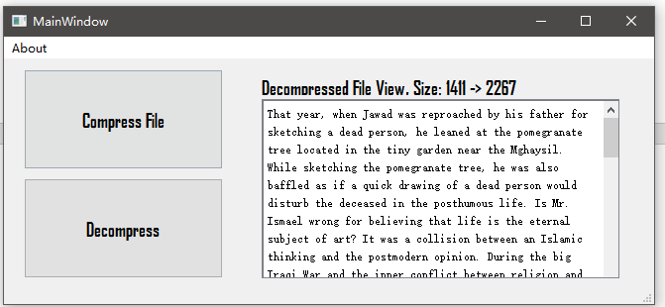

A user instruction video is uploaded along with the source code.